

**Bushfire Brigade: Interactive Learning for Young Victorians' Bushfire Preparedness**

FIT5120 Iteration 2 Analysis & Design Report

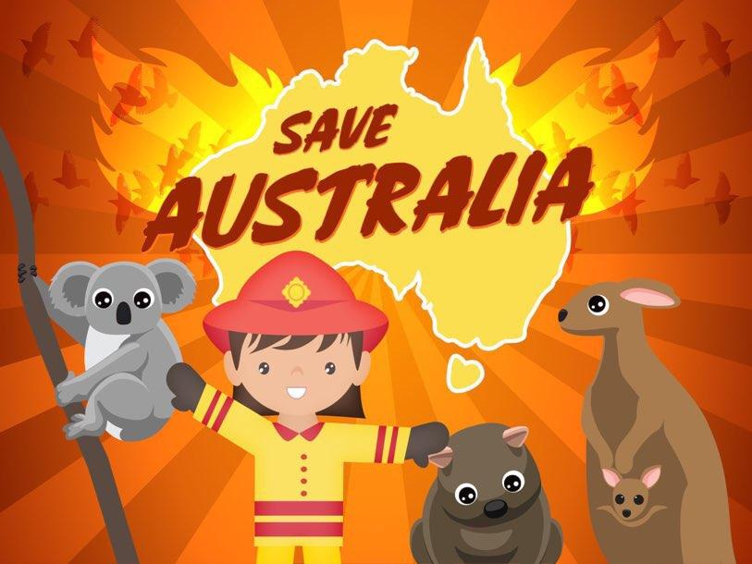

**By: Next Gen Innovators**

**Manya Bhatia (30488575)**

**Maherali R Vijapura (33633215)**

**Siramade Apivirasirikul (33037078)**

**Chandara Khvan (33527245)**

**Thinithi Bulathsinghala (27523306)**

**Introduction**

This report presents the analysis and design of Bushfire Brigade, a web application aimed at children between the ages of 8 and 12 living in bushfire-prone areas in Victoria. The report provides an overview of the project, outlining the problem statement, target audience, and key features, linking each feature to specific User Stories and Acceptance Criteria as identified in the LeanKit.

**Project Overview**

**Problem Statement**

As Victoria faces an escalating bushfire risk due to climate change, there is a pressing need to enhance bushfire education for children aged 8-12. Current educational programs are often too abstract, failing to provide the practical understanding and skills necessary for children to respond effectively in real-life bushfire situations (SBS News, 2020). This lack of realistic education leaves young Victorians living in Bushfire Prone Areas vulnerable and unprepared for emergencies. There is a need for more tangible, experience-based bushfire education that better equips children to understand the dangers and respond appropriately, ensuring their safety and resilience.

**Project Summary**

In Victoria, children in bushfire-prone areas face increased risks from climate-related bushfires. Traditional educational methods are often too abstract, leaving them unprepared for emergencies. There is also a noticeable lack of education specifically regarding bushfires within Australian schools, with many students feeling that they are not being educated enough about protecting themselves and their communities (Gough & Towers, 2020). Studies from the University of Melbourne also show that bushfire trauma can significantly disrupt schooling and slow the developmental progress of affected children, emphasising the need for improved educational approaches that acknowledge and address the psychological impacts (Trounson, 2019). Additionally, a lack of direct knowledge about appropriate bushfire responses among children underscores the urgent requirement for curriculums that are both relevant and relatable to the Australian context (Towers, 2015). As bushfires become more frequent and intense, it becomes crucial to reformulate how we educate our youth on this subject, shifting towards more interactive and experience-based learning strategies that can effectively prepare them for such events (Pooley et al, 2021). The Bushfire Brigade website, designed for children aged 8-12, offers interactive tools like games, videos, and quizzes to provide practical bushfire safety knowledge. This new approach to bushfire education aims to better prepare young Victorians by equipping them with necessary skills and confidence.

**Target Audience**

| **Persona** | **Children aged 8-12 in BPA’s** | **Guardians/Parents and Teachers** |
| --- | --- | --- |
| **Name** | Jack | Laura |
| **Age** | 10 | 36 |
| **Location** | Victoria, Australia | Victoria, Australia |
| **Lifestyle** | Active and curious, enjoys outdoor activities and exploring nature; lives in bushland and is familiar with the Australian bush. | Primary School Teacher and Mother; Active community member focused on safety and education. |
| **Motivations** | Wants to be a bushfire safety "expert," earn badges, and keep his family, especially his younger sister, safe. | Ensuring her family and students are prepared for bushfire emergencies. |
| **Goals** | Learn bushfire safety through engaging, interactive games and videos; feel confident and prepared. | To integrate engaging, comprehensive bushfire safety resources into her teaching and parenting. |
| **Pain Points** | Finds bushfire safety information boring and complex; feels anxious and overwhelmed; frustrated with traditional, unengaging lessons. | Struggles to find age-appropriate, engaging bushfire safety resources; Time-consuming to compile comprehensive resources from multiple sources; Challenges in maintaining student interest with traditional safety drills and materials. |

**Iteration 2**A summary of each Feature and how it links to the EPICS and User Stories for the project can be found in the project’s detailed [Epics document](https://docs.google.com/spreadsheets/d/1Ipc1_5vNhHUefrYgeByAbiWg_8WksC1c/edit?gid=246288868#gid=246288868) and [LeanKit](https://monashie.leankit.com/board/2176289636). The key deliverables include:

### **Interactive Map for Bushfire Risk:** An interactive map that shows bushfire severity across Victoria, overlaid with school locations. Children can search for their school and view the bushfire risk level in their area. **Importance:** *This map helps children visualise the bushfire risks around their school, making the concept of bushfire severity more tangible and relevant to their lives.*

### **Related User Story:** US4.1 - "Bushfires Matter to All Victorians," where children understand the significance of bushfires in Victoria and learn about the risks they might face.

### **Seasonal Bushfire Variation bar chart:** A bar chart that displays the seasonal variation of bushfire incidents over the years in Victoria, with interactive features allowing children to explore the data. **Importance:** *This chart educates children on how bushfire risks vary by season, fostering a better understanding of when they are most vulnerable and why staying vigilant is important.* **Related User Story:** US4.2 - "Preparing for the Bushfire Season," where children explore how the likelihood of bushfires changes throughout the year and understand the importance of being prepared.

### **Bushfire Survival Flowchart and Emergency Help Interface:** This feature combines a cartoon-style flowchart with an emergency help interface featuring Australian animals as Triple Zero agents. It teaches bushfire survival skills and provides clear, voice-guided instructions for getting help during an emergency.

### **Importance:** *This feature teaches children vital survival skills and emergency procedures in an engaging and accessible way.*

### **Related User Stories:**US5.1 and US5.2: Children learn essential survival skills and how to seek help during a bushfire, guided by familiar characters.

1. **Bushfire Danger Rating for Schools**

**Description:** This feature displays a fire danger rating for schools based on bushfire occurrences in the surrounding areas, using both historical and real-time data to provide accurate risk assessments.

**Importance:** *Enables schools to understand their specific bushfire risks, promoting better preparedness and informed decision-making.*

**Related User Story:** US4.3 - "Assessing School Bushfire Risk" - Children and schools gain valuable insights into the bushfire risks specific to their area, reinforcing the importance of being prepared.

### **Changes from the Previous Iteration (Iteration 2)**

In **Iteration 2**, the focus shifted from simply learning about the causes and factors of bushfires to understanding the risks and being better prepared for such events. This iteration introduced several key changes and new features to enhance the educational experience:

1. **Expanded Focus on Risk Understanding and Preparedness**:
   * **Previous Iteration**: The primary focus was on educating children about the basic causes and contributing factors of bushfires, such as weather, vegetation, and topography.
   * **Current Changes**: This iteration shifts towards helping children understand the risks associated with bushfires and how to prepare for them. It introduces features that help children identify if they are at risk, what actions to take, and how to stay vigilant, particularly through interactive maps, survival planning tools and risk scores. *Analytics based bushfire risk score derivation is initiated as well*.
2. **Incorporation of Audio Elements**:
   * **Previous Iteration**: The content relied solely on visual and text-based elements, which may not have been accessible to all learners, especially those who have difficulty reading.
   * **Current Changes**: To enhance accessibility and engagement, audio elements have been introduced throughout the platform. This includes voiceovers explaining bushfire risks and survival plans, as well as audio instructions accompanying visual elements. These audio features ensure that children who struggle with reading or prefer auditory learning can still fully engage with the material.
3. **Introduction of Testing Quizzes with Question and Answer Reveal Functionalities**:
   * **Previous Iteration**: There were no interactive testing mechanisms in place to assess children's understanding of the material.
   * **Current Changes**: This iteration incorporates testing quizzes that allow children to answer questions about bushfire safety and preparedness. After submitting their answers, the correct answers are revealed along with explanations, reinforcing the learning process. This interactive approach not only tests comprehension but also deepens the learning experience by providing immediate feedback.

**References**

Andrew, T. (2019, January 24). *Bushfire trauma puts schooling at risk*. Pursuit; University of Melbourne. <https://pursuit.unimelb.edu.au/articles/bushfire-trauma-puts-schooling-at-risk>

Gough, A., & Towers, B. (2020, August 28). *More bushfires, less volcanoes: young Australians need to learn about more relevant disasters*. The Conversation. <https://theconversation.com/more-bushfires-less-volcanoes-young-australians-need-to-learn-about-more-relevant-disasters-145163>

SBS News. (2020, January 22). *Bushfire education is too abstract. We need to get children into the real world*. <https://www.sbs.com.au/news/insight/article/bushfire-education-is-too-abstract-we-need-to-get-children-into-the-real-world/xyq7cbfsy>

Towers, B. (2015). Children’s knowledge of bushfire emergency response. *International Journal of Wildland Fire, 24*(2), 179-189.

Pooley, D. K., Nunez, S., & Whybro, M. (2021, April 1). *Ajem April 2021 - evidence-based practices of effective fire safety education programming for children*. Australian Disaster Resilience Knowledge Hub. <https://knowledge.aidr.org.au/resources/ajem-april-2021-evidence-based-practices-of-effective-fire-safety-education-programming-for-children/>